New visualizations :

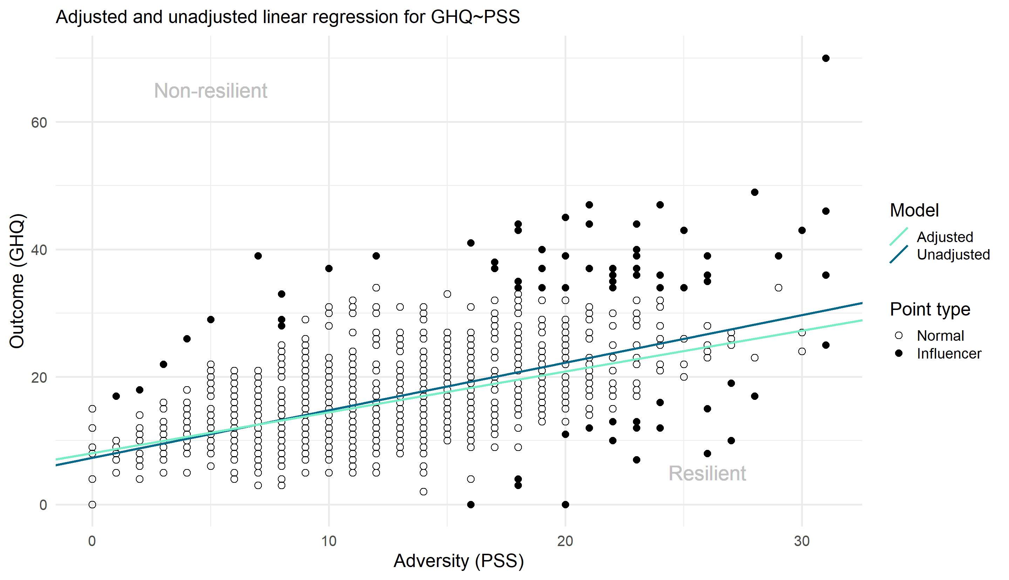
Figure X: Residualization of GHQ and PSS
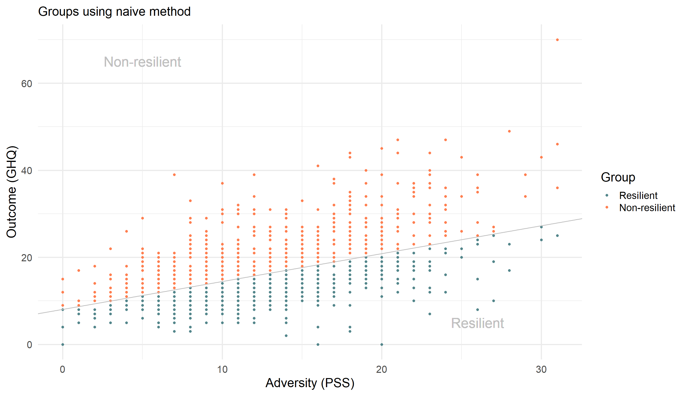
Figure X: Classification obtained with the naive approach for PSS

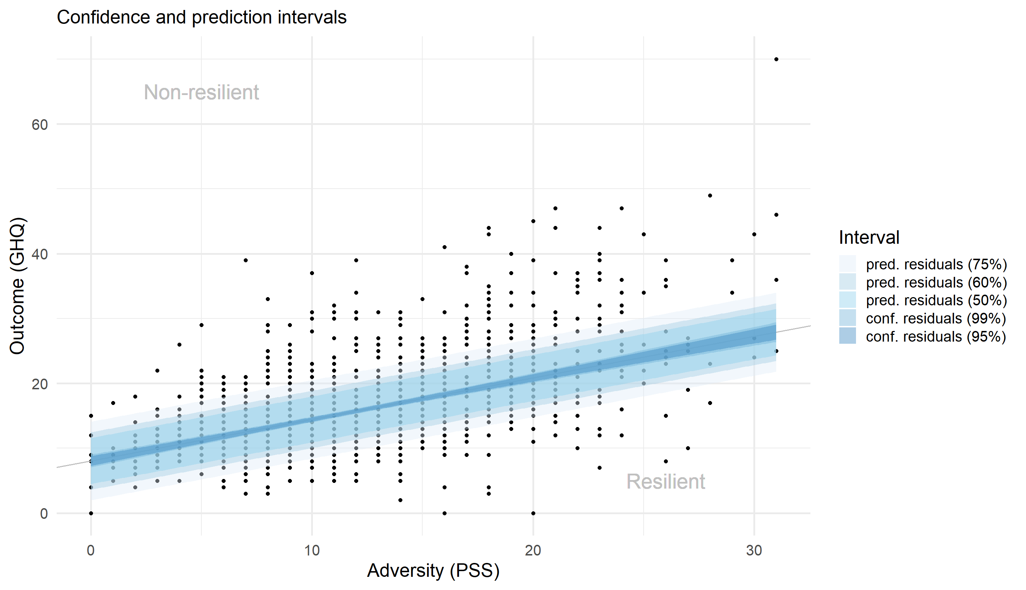
Figure X: Classification obtained with the confidence and prediction intervals approaches for PSS

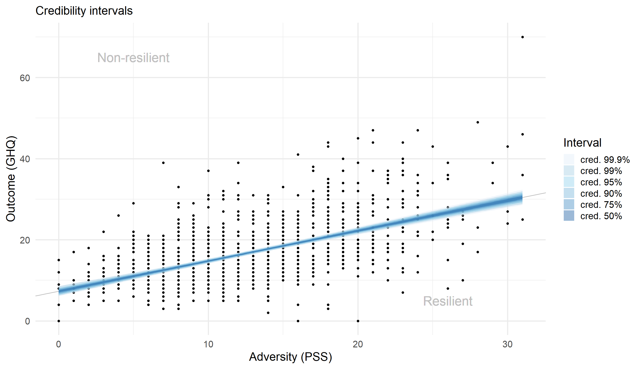
Figure X: Classification obtained with the credibility interval approach for PSS

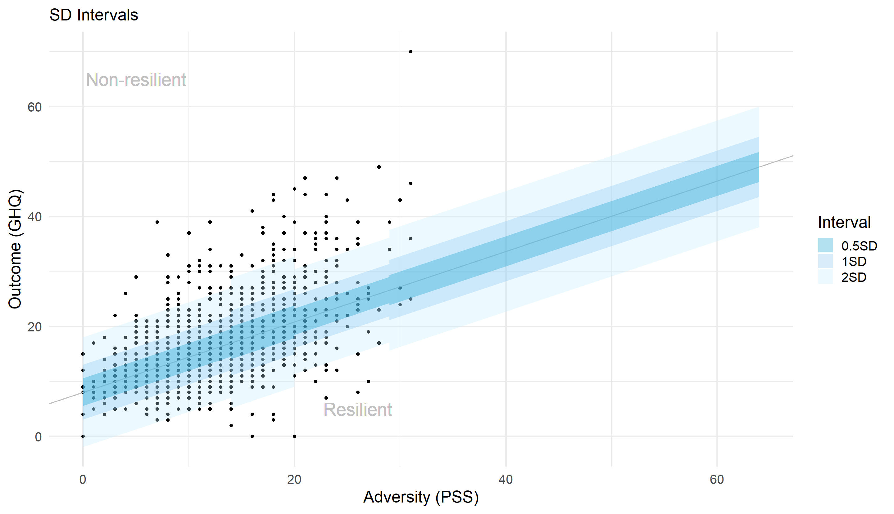
Figure X: Classification obtained with the standard deviation based approach for PSS

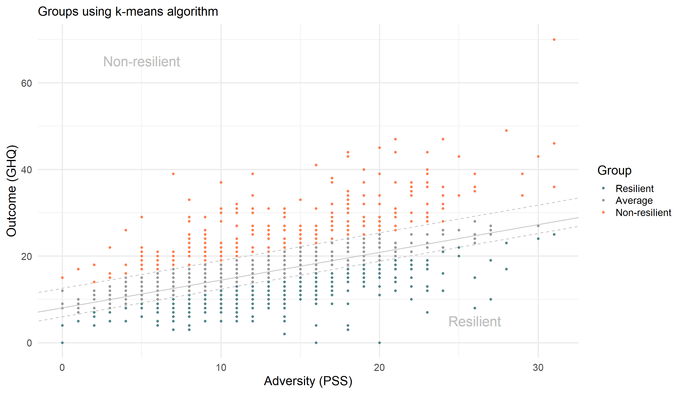
Figure X: Classification obtained with the k-means method for PSS

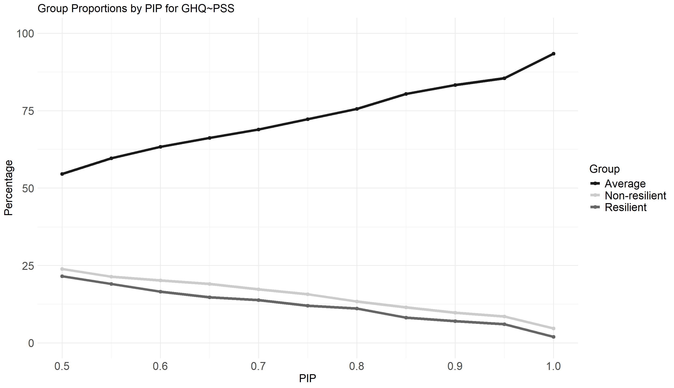
Figure X: Proportions of individuals in each category depending on the chosen PIP threshold for GHQ~PSS.
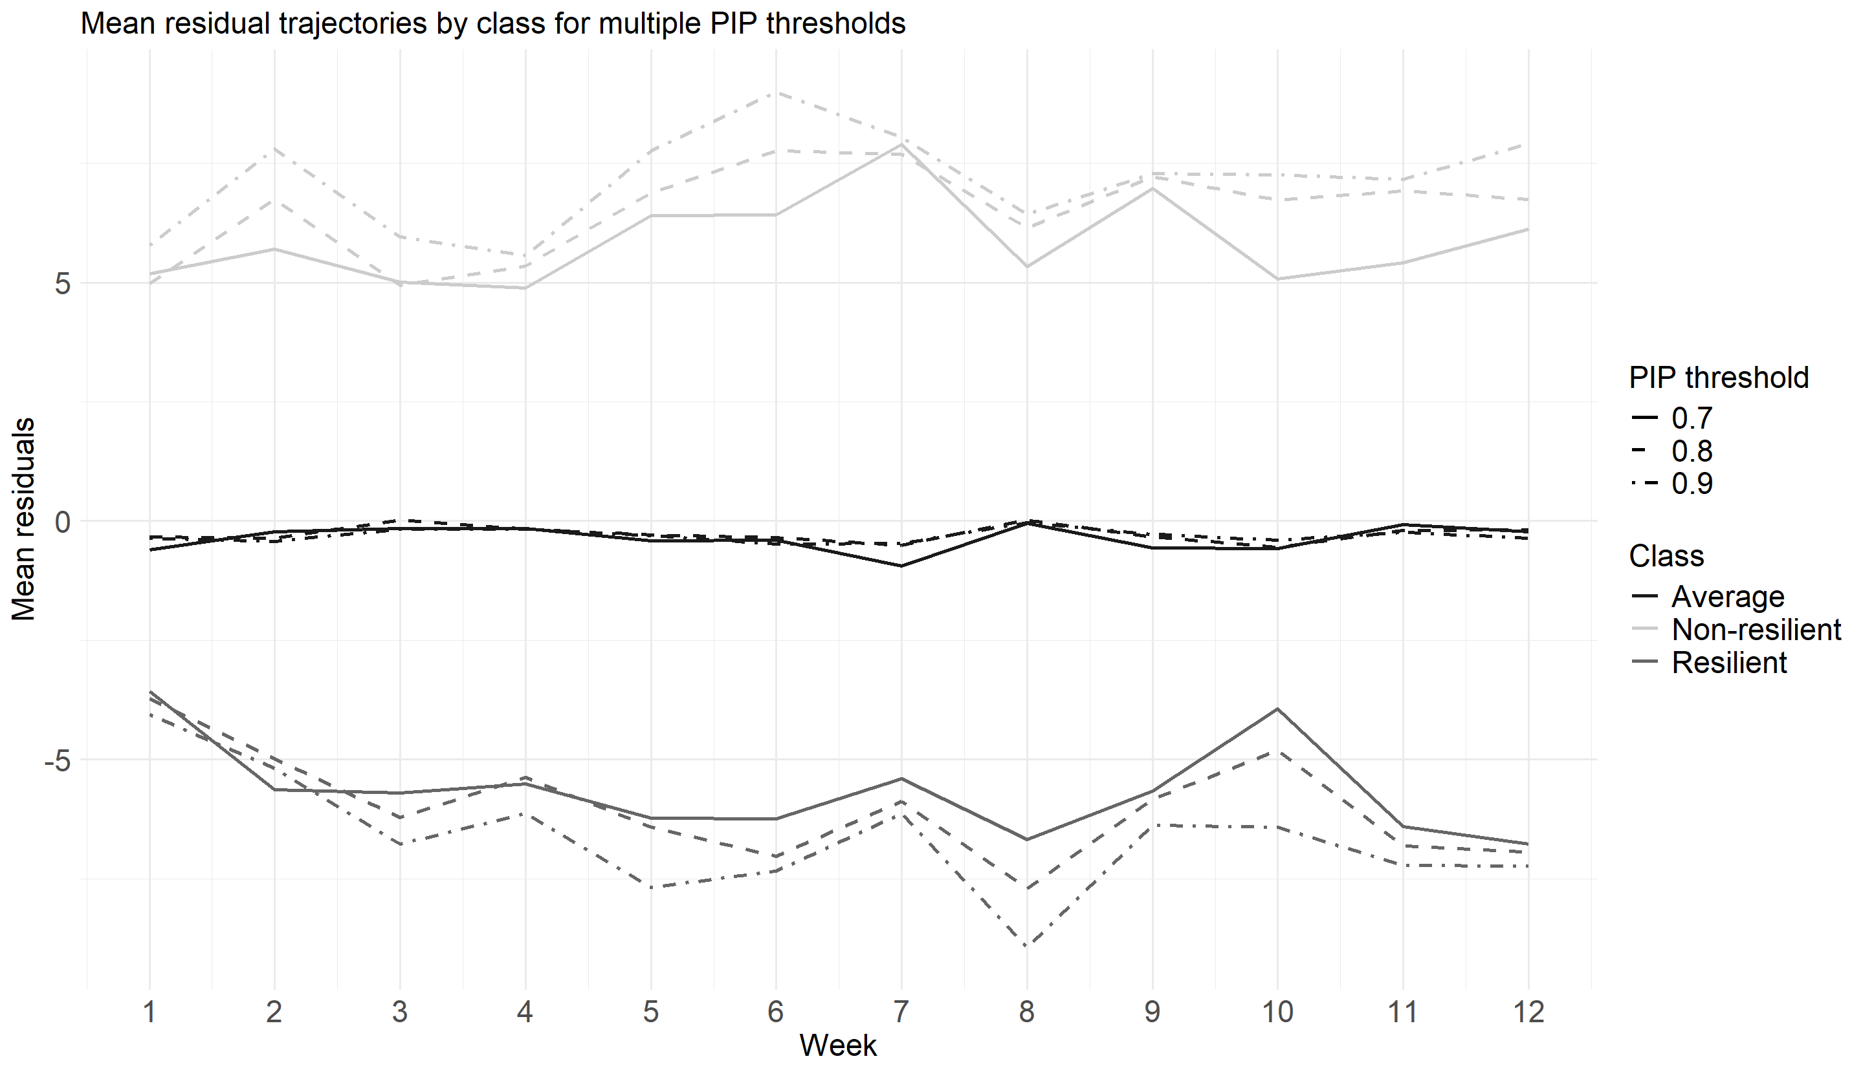
Figure X: Evolution of the mean residuals for each group using different thresholds to build the groups for PSS
Table presenting the approaches
Approach | Description | Strictness (average group size)
Naive | Non-zero residuals = non-average. | Very strict, almost no average group
Confidence | Outside confidence interval of residuals = non-average. (Interval for mean estimate) | Strict, narrow interval, small average group, but depends on chosen %.
Prediction | Outside prediction interval of residuals = non-average. (Interval for new observation) | Moderate, wider than confidence intervals, but depends on chosen %.
Credibility | Bayesian equivalent of confidence interval. | Strict, narrow interval, small average group, but depends on chosen %.
Quantiles | Outside n% - (100–n)% quantile range = non-average. | Flexible, smaller n implies larger average group.
Standard-deviation | Residuals beyond multiple × SD within adversity group = non-average. | Flexible, larger multiple implies larger average group.
K-means | Cluster residuals into 3 groups using k-means. | Variable, depends on data structure.
Table X: Concise description of all approaches

Longitudinal analysis: evaluation of predictive relevance

Informations:
- Only 515 individuals present for the first 12 weeks and having less than 30% of missing data for the predictive variables.
- Redid the spike and slab on that sample.
- Same predictive variables as for the cross-sectional analysis.
- Did the exact same thing as for the cross-sectional part: missForest for missing data, VIF variable selection, 10 folds cross-validation

For PSS, the average group becomes dominant when the PIP threshold is >= 0.35
For DH, the average group becomes dominant when the PIP threshold is >=0.4

Sums
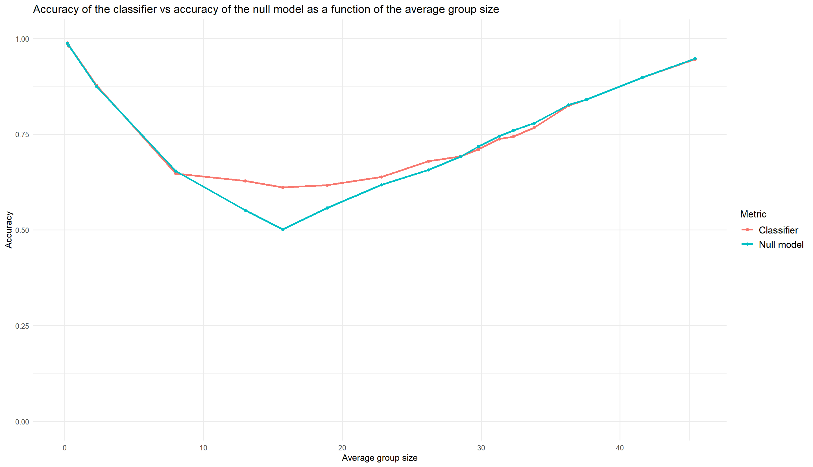
Figure X : Evolution of the mean accuracy of the classifiers and the accuracy of the null model as a function of the average group size for DH with sums and subscales as predictors
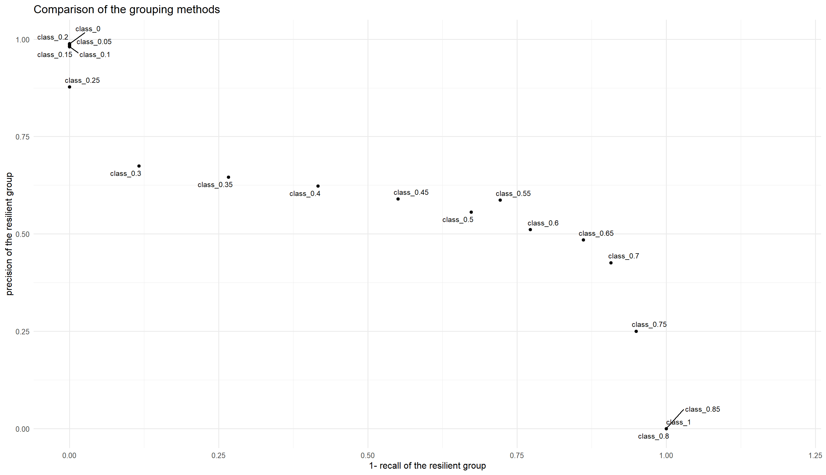
Figure X : Recall and precision of classifiers for DH with sums and subscales as predictors
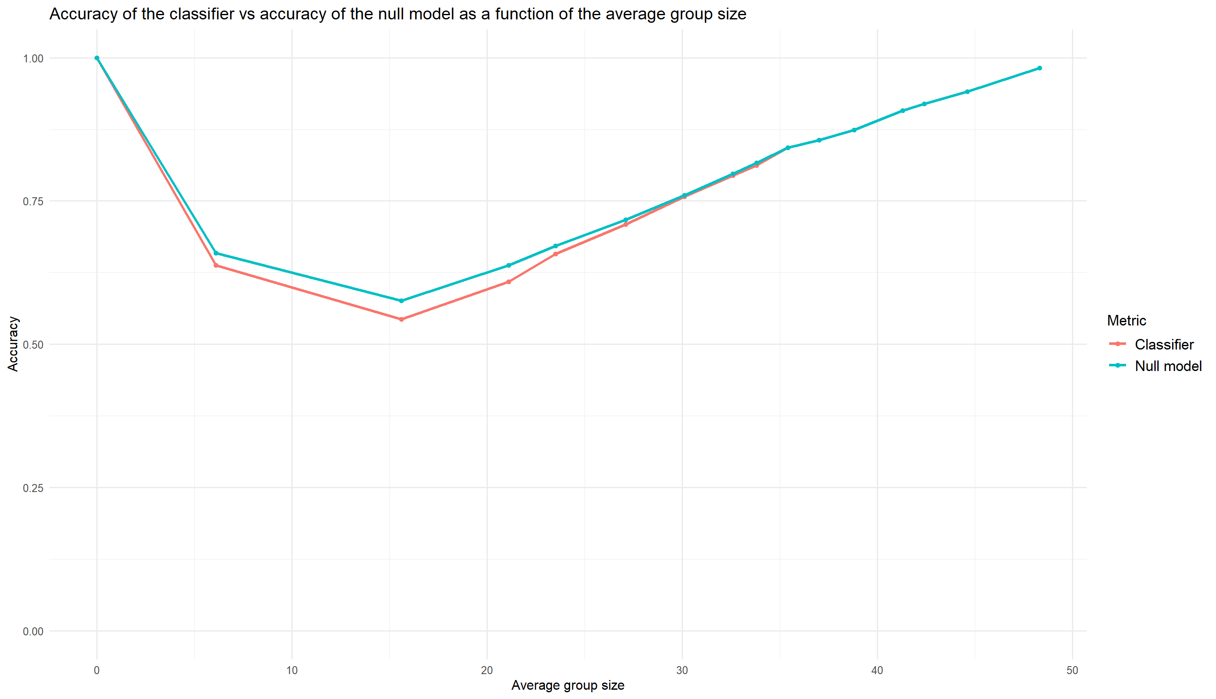
Figure X : Evolution of the mean accuracy of the classifiers and the accuracy of the null model as a function of the average group size for PSS with sums and subscales as predictors

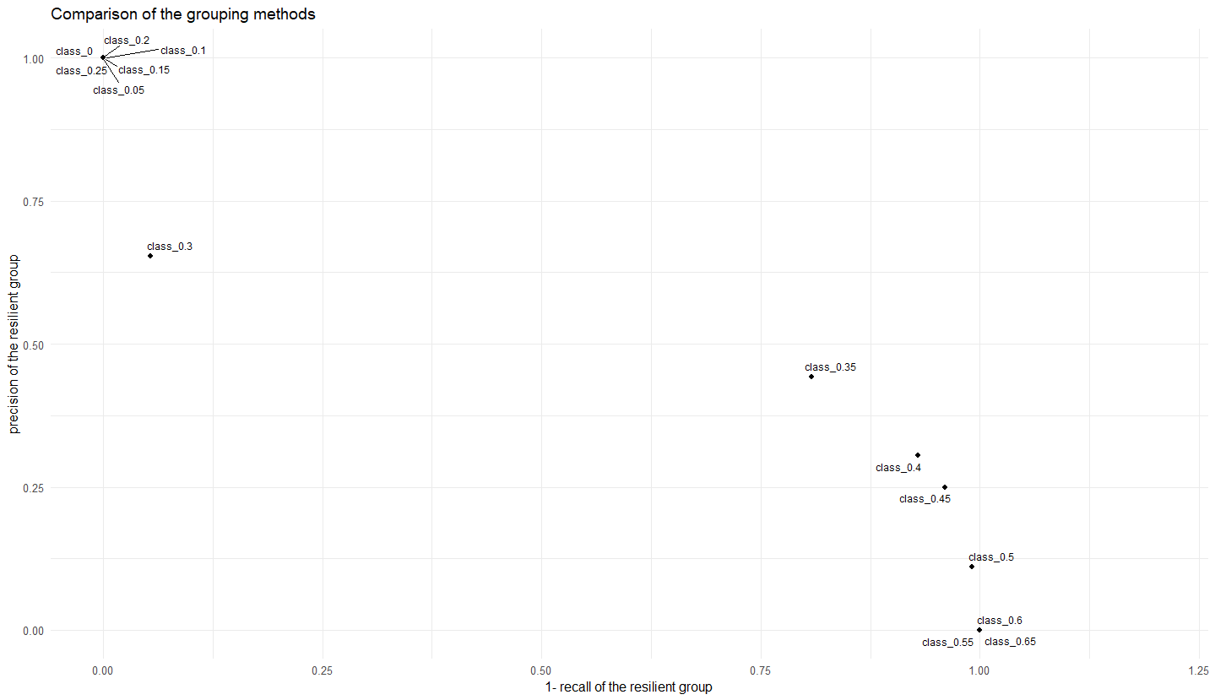
Figure X : Recall and precision of classifiers for PSS with sums and subscales as predictors
Items
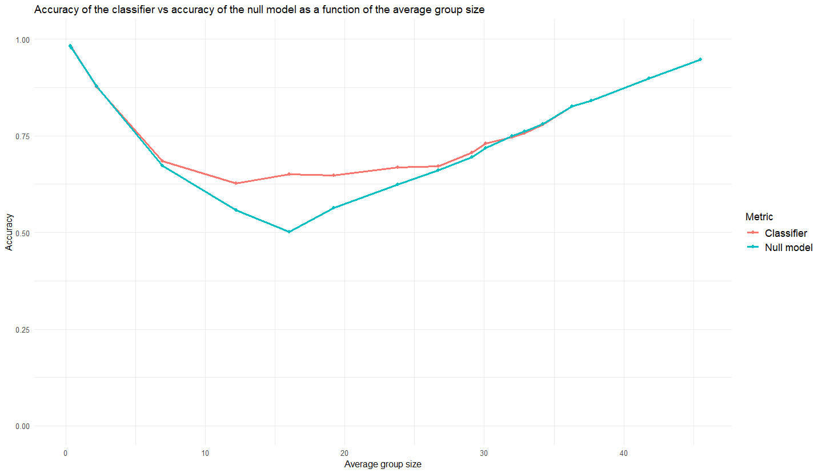
Figure X : Evolution of the mean accuracy of the classifiers and the accuracy of the null model as a function of the average group size for DH with items as predictors
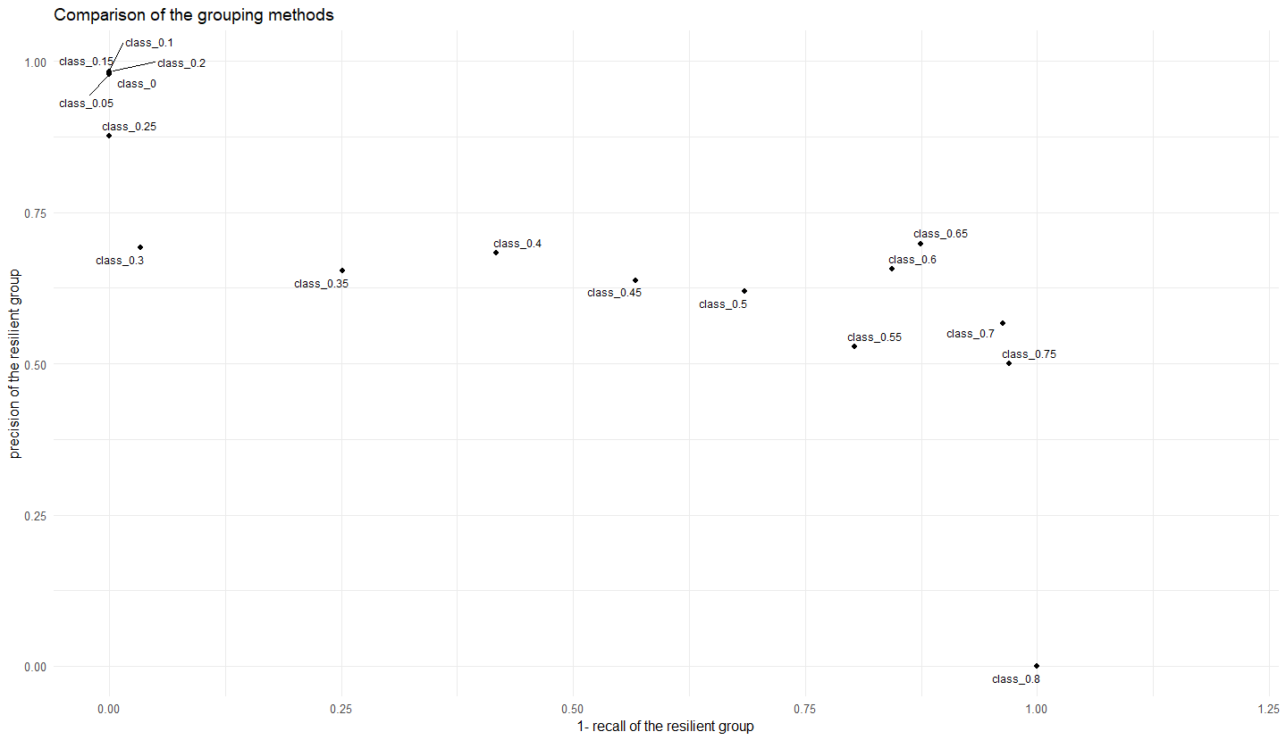
Figure X : Recall and precision of classifiers for DH with items as predictors
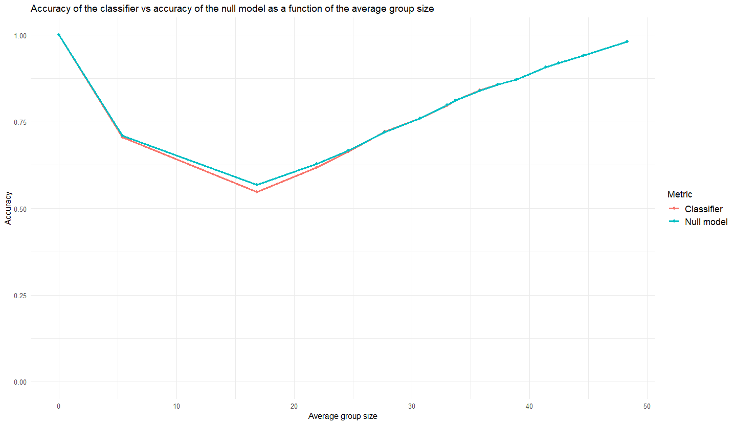
Figure X : Evolution of the mean accuracy of the classifiers and the accuracy of the null model as a function of the average group size for PSS with items as predictors
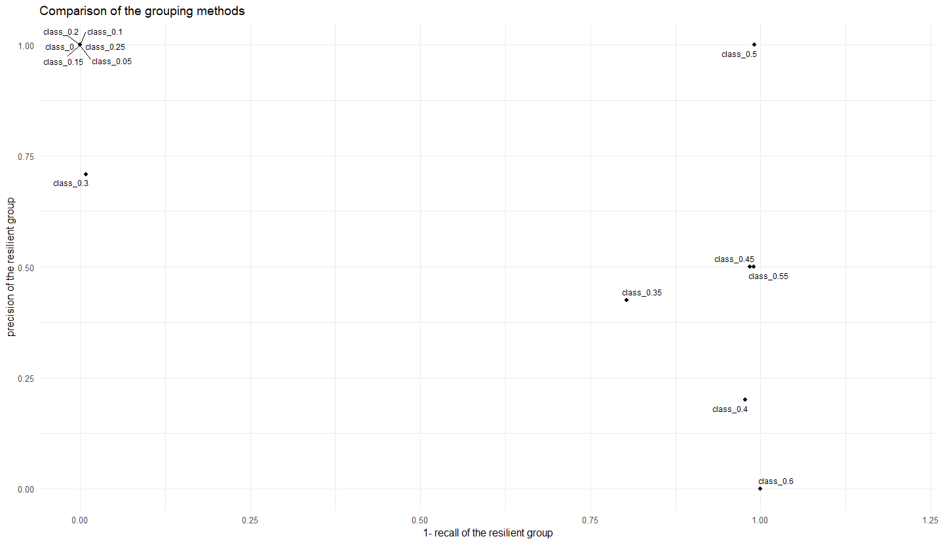
Figure X : Recall and precision of classifiers for PSS with items as predictors

